Stock pitch
Buy: Meta; current price: target price 580 by the end of this year
• Addressable market: AI application.
o Meta is among the world’s largest companies and also the leading social media giant. It is at the forefront of the current AI wave. We've all witnessed the surge in Nvidia's stock, driven by the skyrocketing demand for AI infrastructure. With ChatGPT now entering its second year and Nvidia possibly already halfway through its high-growth phase, it might be a good time to consider future winners in AI applications. I would say Meta will definitely be one of the top ones. While AI is currently most widely used in chatbots, text summarization, and coding, Meta has shown a strong capability in commercializing AI for digital advertising.
• Products:
o The company operates through two segments: Family of Apps and Reality Labs. The Family of Apps includes Meta’s social media platforms such as Facebook, Instagram, WhatsApp, and Threads. Reality Labs, on the other hand, focuses on research and offerings in virtual reality (VR), with products like their VR glasses developed in collaboration with Ray-Ban. We know that the Reality Labs has been a financial drag on Meta’s revenue for years, but the company recently announced the cancellation of its Vision Pro-like headset that they had been developing. With this shift, the focus is now primarily on the glasses, and I believe this pivot could soon help Meta turn around its Reality Lab losses.
o Now, turning to the major part of Meta’s operations—the Family of Apps. This is where Meta is focusing on building its AI ecosystem and starting to generate significant profits directly from AI. It's important to note that two key components are essential for developing a strong AI: computing power and data.
o First, regarding computing power, Meta is known for its substantial spending in AI infrastructure. It is the company that has purchased the largest number of GPUs from Nvidia. Additionally, Meta has a strong balance sheet with significant cash on hand, allowing them to acquire even more resources as needed. They have also collaborated with Broadcom to develop their own ASIC chips, positioning themselves at the forefront of the AI arms race. (Meta will be broadcom’s next multi-billion dollar customer after google)
o Then talking about data. Thanks to its family of apps, Meta has a very broad base of customers. It has over 3 billion monthly active users, that is about half of the world’s population. Meta’s new platform threads is also gaining a lot of popularity. As of August 2024, Meta's Threads had over 200 million monthly active users (MAU). Although it is still away from Twitter’s more than 500 million user base, the number has been continuously growing and adds significant value to Meta’s ecosystem. This vast user base provides Meta with a wealth of data to train customized AI models and offers a large audience for targeted services, particularly in digital advertising.
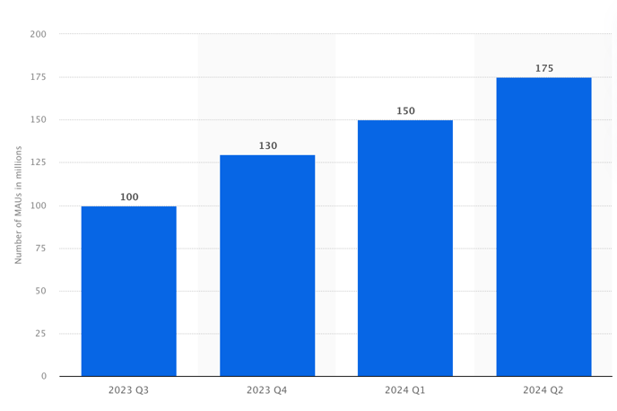
o Meta has now infused its Meta-assistant based on its large language model on all of its platforms. This meta assistant adds monetization and expands formats beyond reels and click-to-messaging ads. For example, the Meta assistant is integrated in whatsapp, and according to the management team, this feature has helped whatsapp to gain a lot more users and could be a near-term catalyst for top-line gains in the US.
o Meta's current focus on using AI is in digital advertising, setting it apart from the crowded, market-dominating competition in cloud services, like those offered by Google, Microsoft, and Amazon. And Meta has integrated its Meta Assistant, powered by its large language model, across all its platforms. This assistant not only provide AI services to users but also expands advertising formats beyond Reels and click-to-messaging ads. A straightforward example is Meta's work in training AI to create ads and target them to the right audience based on AI-driven selection. This process of using large language models to improve ad recommendations and targeting has significantly boosted Meta's monetization efforts. As reflected in its Q2 earnings, thanks to a sequential pickup in ad-pricing gains, Meta's operating margin reached 38%, an increase of about 850 basis points year over year. Revenue grew by 22%, and operating income for its core Family of Apps surged by about 50%. In comparison, during the same period, Google's revenue for its search and YouTube segments grew by only 14% and 13% year over year. This highlights that Meta is a significantly more attractive platform for advertisers and has a superior digital advertising operation.
o Lastly, I want to discuss Meta's large language model, llama. What sets it apart from others is that it is completely open-source. By open-source, I mean that the original source code is freely available for anyone to use, modify, and redistribute. This is particularly appealing to developers, as it allows them to integrate Meta’s state-of- the-art language model into their own applications without any licensing fees. This approach has already attracted many institutions and researchers who leverage LLaMA for their work. It enables developers to incorporate the latest innovations at a low cost while giving institutions more control over their data. The open-source nature of LLaMA could drive widespread adoption. For example, Apple’s Swift programming language is open-source, which has led to widespread development for Apple platforms. Similarly, we might one day see a proliferation of AI software powered by LLaMA, which would be a significant achievement for Meta.
o Lastly, I want to talk about their AI ecosystem. So llama is Meta’s large language model, and what’s different from others is that it is compeletley open-source. By open-source, I mean software for which the original source code is made freely available and may be redistributed and modified. So as a developer, one can incorporate Meta’s state-of-the-art large language model to its own app without any fee. This is so attractive and a lot of institutions and especially researches harness llama for their work, and it lets developers incorporate the latest innovations at low cost and gives institutions more control over their data. The open-source nature of llama could drive wider adoption. For example, apple has its swift code open- sourced, so people can program on Mac and to target applications on all Apple platforms. So maybe one day when we see tons of AI softwares, and llama would be large language model behind them, this would mean so much for Meta.
• Financials:
o Meta’s stock price has been up 62% year to date, and 18% after its earnings report, outperforming big tech peers. However, as we just demonstrated, Meta is still in its high growing phase. Also, from a PE point of view, Meta remains relatively undervalued, with a P/E ratio of around 28, which is still on the lower side compared to other big tech companies—Microsoft at 37, Amazon at 46, and Google at 23.
o Operating margin has been steadily around 40% over this year, the last quarter, it reports a 38%, which is 9% up year over year. Operating income has grown about 50% for its core family of apps. Revenue grew 22% year over year.
o However, we should remain cautious about the current AI hype and the broader macroeconomic uncertainties. Meta’s capital spending has increased by 50% year over year, and while the company appears to be making good use of these investments, this level of spending could still present risks within the industry. Additionally, the economic outlook is uncertain, which adds another layer of risk. Given these factors, I would recommend considering a put option, perhaps around $480, extending through mid-year next year, alongside a long position.
o Ebitda margin 48.30 %

